# Welcome Supplier Administrator

1. Log into the [vendor portal](https://lagoverpvendor.doa.louisiana.gov/irj/portal) with your ID (11 digit vendor number that begins with a “V”) and your personal password.

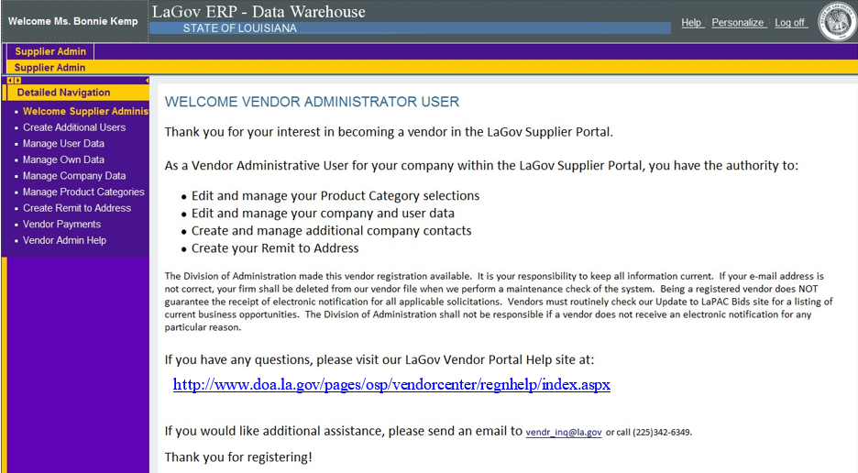

1. Once you have registered, you can click on the left navigation pane to perform administrator functions. Help scripts exist for each of the topics on the Vendor Resources > [Registration Information page](https://www.doa.la.gov/doa/osp/vendor-resources/registration-information/).