DECLARATION OF EMERGENCY
Department of Wildlife and Fisheries
Wildlife and Fisheries Commission
Chronic Wasting Disease Control Areas
Editor's Note: This Emergency Rule, originally printed on pages 476-477 of the April 20, 2026 issue of the Louisiana Register, is being republished to correct an error upon submission.

A confirmed case of Chronic Wasting Disease (CWD) has been detected in a white-tailed deer harvested in Ouachita Parish. CWD is a neurodegenerative disease found in most deer species, including white-tailed deer. It is infectious, always fatal, and has no treatment. CWD is part of a group of diseases know as transmissible spongiform encephalopathies (TSEs). These diseases cause irreversible damage to brain tissue in deer, which leads to excessive salivation, neurological symptoms, emaciation, and death of the animal. Additionally, CWD is shed by infected deer onto the landscape and can persist in the environment indefinitely, spreading the disease to other deer. Emergency action is required to mitigate further spread of the disease.

In accordance with the emergency provisions of R.S. 49:962 and R.S. 56:6.1, the secretary of the Department of Wildlife and Fisheries hereby modifies the CWD Control Area established in LAC 76:V.137 to include an area surrounding where the confirmed CWD case was detected in Ouachita Parish as follows:
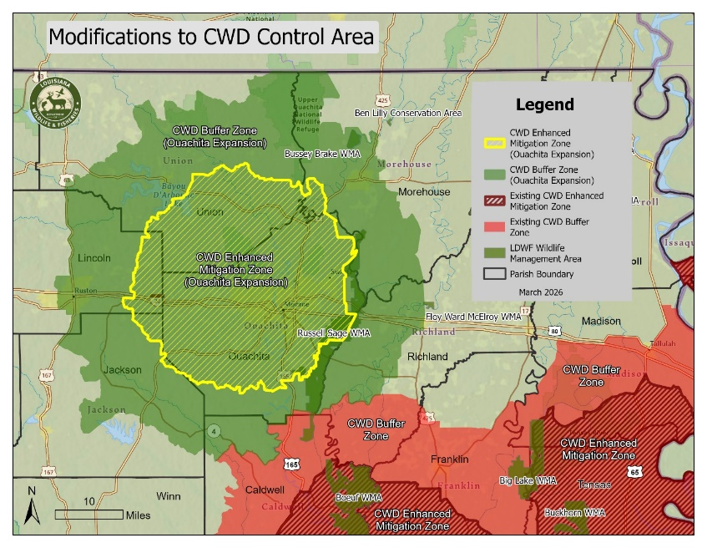

Supplemental feeding, baiting, placement of bait, or hunting over bait is prohibited within the portion of the CWD Control Area designated as the CWD Enhanced Mitigation Zone. It is the responsibility of hunters to check their hunting area for bait prior to each hunt. A baited area is an area on which salt, grain, or other feed has been placed, exposed, deposited, distributed, or scattered, if that salt, grain, or other feed could serve as a lure or attractant for wild quadrupeds or wild birds via ingestion. Supplemental feeding and baiting is allowed in the portion of the CWD Control Area designated as the CWD Buffer Zone, but only by non-stationary, mechanical or electronic broadcast methods. The use of bait not normally ingested by deer is allowed for feral hog trapping, or by holders of bear harvest permits during the designated bear baiting period.

The export of any cervid carcass or part of a cervid carcass originating within a designated CWD Control Area is prohibited, except for: meat that is cut and wrapped; meat that has been boned out; quarters or other portions of meat with no part of the spinal column or head attached, antlers, clean skull plates with antlers, cleaned skulls without tissue attached, capes, tanned hides, finished taxidermy mounts, and cleaned cervid teeth. An exemption for deer heads from within the CWD Control Area transported to Louisiana taxidermy businesses for taxidermy purposes outside of the CWD Control Area is allowed by electronic waiver and adherence to waiver guidelines.

Approved parts transported out of the CWD Control Area must be legally possessed. Approved parts must contain a possession tag with the hunter’s name, address, LDWF license number, parish of harvest, date of harvest, and sex of deer. All cervid parts transported out of the Control Area that are in violation of the provisions of this ban shall be seized and disposed of in accordance with the Wildlife and Fisheries Commission and Department of Wildlife and Fisheries rules.

This Declaration of Emergency shall be effective March 11, 2026 and shall remain in effect for 180 days, unless superseded by action taken by the Wildlife and Fisheries Commission. The implementation of the supplemental feeding and baiting prohibition associated with the newest addition to the Enhanced Mitigation Zone shall be delayed until April 1, 2026, so that landowners and hunters have an opportunity to use the remainder of any feed or bait they currently have in feeders.

Tyler M. Bosworth
Secretary
2605#006

