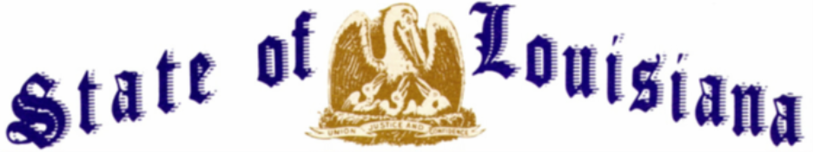
EXECUTIVE DEPARTMENT
OFFICE OF THE GOVERNOR
EXECUTIVE ORDER NUMBER JML 26-080
_____________________________________________________________________________
FLAGS AT HALF-STAFF
GURNIE “TUTIE” RICHARD
______________________________________________________________________________

WHEREAS, Gurnie Joseph “Tutie” Richard made the ultimate sacrifice to our country on November 26, 1942;
WHEREAS, he was born to Lester and Louise Daigle Richard on August 27, 1920, in Vinton, Louisiana;
WHEREAS, he attended Vinton High School and was a part of the 1935-1936 Football State Championship team, alongside his brother;
WHEREAS, shortly after his 20th birthday, he answered his nation’s call with unwavering resolve, enlisting in the United States Army Air Corps;
WHEREAS, he was deployed to the Philippines with the 17th Bombardment Squadron, 27th Bombardment Group on November 20, 1941, as part of the buildup of United States Army Forces in the Far East;
WHEREAS, after resisting enemy forces for four months while suffering from a lack of food, medicine, and ammunition, the United States forces surrendered on the Bataan Peninsula on April 9, 1942;
WHEREAS, following the surrender, he was taken as a prisoner of war;
WHEREAS, he was among the approximately 75,000 American and Filipino American prisoners of war forced into the brutal 65-mile Bataan Death March, one of the most horrific trials of World War II;
WHEREAS, he met this profound cruelty with a courage that continues to inspire and humble us;

WHEREAS, following the Bataan Death March, he was imprisoned at the Cabanatuan POW Camp #1, where disease was rampant due to horrendous conditions;
WHEREAS, facing this relentless hardship and extreme nutritional deprivation, he died on November 26, 1942;
WHEREAS, because so many were losing their lives at Cabanatuan Camp #1, the camp adopted a mass interment system, burying all who died in a single day in a common grave;
WHEREAS, the United States Army Quartermaster Corps’ American Graves Registration Service exhumed much of the Cabanatuan Camp #1 graves from December 1945 through March 1946, including the grave in which Gurnie Joseph Richard was buried;
WHEREAS, in August 1949, he was declared nonrecoverable, as there were no additional leads which could aid in identifying his remains;
WHEREAS, under the leadership of President Donald J. Trump, Technician, Fifth Grade Gurnie Joseph Richard is coming home on August 20, 2026, 84 years later, to be laid to rest with his parents;
WHEREAS, he was followed in death by his parents, Lester and Louise Daigle Richard; two siblings, Virgie Richard Singleton and Bernie J. Richard; his niece, Mary Dee Richard Nicks; and his nephew, Don Reese Richard;
WHEREAS, he is survived by his nieces, Joy Singleton Parrott of Youngsville, Louisiana and Jane Anne Richard of Lake Charles, Louisiana; along with numerous great-nieces and great-nephews;
WHEREAS, his death in service to our country remains a solemn reminder of the price paid by those who fought for freedom, and the State of Louisiana honors him with the profound gratitude he so deeply earned;
NOW THEREFORE, I, JEFF LANDRY, Governor of the State of Louisiana, by virtue of the authority vested by the Constitution and the laws of the State of Louisiana, do hereby order and direct as follows:
Section 1: As an expression of respect and to honor Gurnie Joseph “Tutie” Richard, the flags of the United States and the State of Louisiana shall be flown at half-staff over the State Capitol and all state buildings from sunrise until sunset on Thursday, August 20, 2026.

Section 2: This Order is effective upon signature and shall remain in effect until sunset, on August 20, 2026.
IN WITNESS WHEREOF, I have set my hand officially and caused to be affixed the Great Seal of Louisiana in the City of Baton Rouge, on this 17th day of August 2026.

__________________________________________Jeff Landry
GOVERNOR OF LOUISIANA

ATTEST BY THE SECRETARY
OF STATE

__________________________________
Nancy Landry
SECRETARY OF STATE

