# Manage Own Data

1. Log in to the [vendor portal](https://lagoverpvendor.doa.louisiana.gov/irj/portal) with your ID (11 digit vendor number that begins with a “V”) and your personal password.
2. Click on “Manage Own Data” under “Detailed Navigation” on the left. The following screen will appear. To make changes, click the “Change” button at the top of the screen.
3. After you click the “change” button, you will be able to edit fields of your Profile Information.
   1. To edit a field, click on the field, delete the unwanted text and enter the updated information. Multiple fields may be updated at the same time.
   2. To change the signature authority, you can check or uncheck as appropriate.

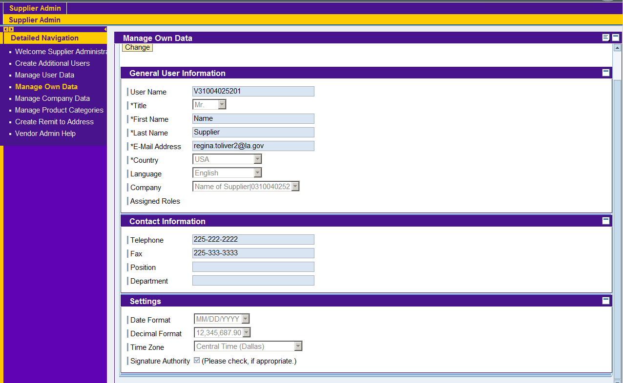

1. Click the “save” button at the top of the screen.

You will be able to view your updated information on the displayed screen.

