# Purchase Order Email Election

1. As the vendor administrator, if you need to update your record, please access by clicking on the ‘PO Email Election’ option in the Detailed Navigation pane:

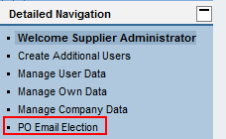

1. You will be directed to a page with the option to change your selection:

