2 0 2 0 Community Development - CV - HVAC Program
Environmental Assessment Checklist
Instructions: Summarize the findings from the EA Worksheet here by choosing the appropriate determination in the determination column for each resource. Then, cite the source document in the appropriate column.
 | Resource | Determination | Source Documentation
 | Land Development
1. | Conformance with Comprehensive Plans and Zoning | Choose from list:  ___ Not Applicable (State Why)  ___ In Conformance  ___ Zoning Permit Required  ___ Project Modification Required
2. | Land Use  Compatibility and  Urban Impact | Choose from list:  ___ Not Applicable (State Why)  ___ Compatible  ___ Land Use Change Required  ___ Project Modification Required
3. | Slope and Erosion | Choose from list:  ___ Not Applicable (State Why)  ___ Slight Slope – No Impact  ___ Moderate to Steep Slope –  Considered in Project Design  ___ Project Modification Required
4. | Soil Suitability | Choose from list:  ___ Not Applicable (State Why)  ___ No Evidence of Soil Issues  ___ Project Design Includes Soil Mitigation  ___ Project Modification Required
5. | Hazards and  Nuisances and Site  Safety | Choose from list:  ___ Not Applicable (State Why)  ___ No Impact  ___ Hazards and Nuisances Considered in Project Design  ___ Project Modification Required
6. | Energy Consumption | Choose from list:  ___ Not Applicable (State Why)  ___ Energy Conservation Measures in Project Design  ___ Project Modification Required
 | Socioeconomic Factors
7. | Demographic  Character Changes | Choose from list:  ___ Not Applicable (State Why)  ___ No Impact  ___ Project Modification Required
8. | Displacement | Choose from list:  ___ No Displacement  ___ Displacement and Payment covered by Uniform Relocation  Act  ___ Project Modification Required ___ Other (Describe)
2 0 2 0 Community Development - CV - HVAC Program

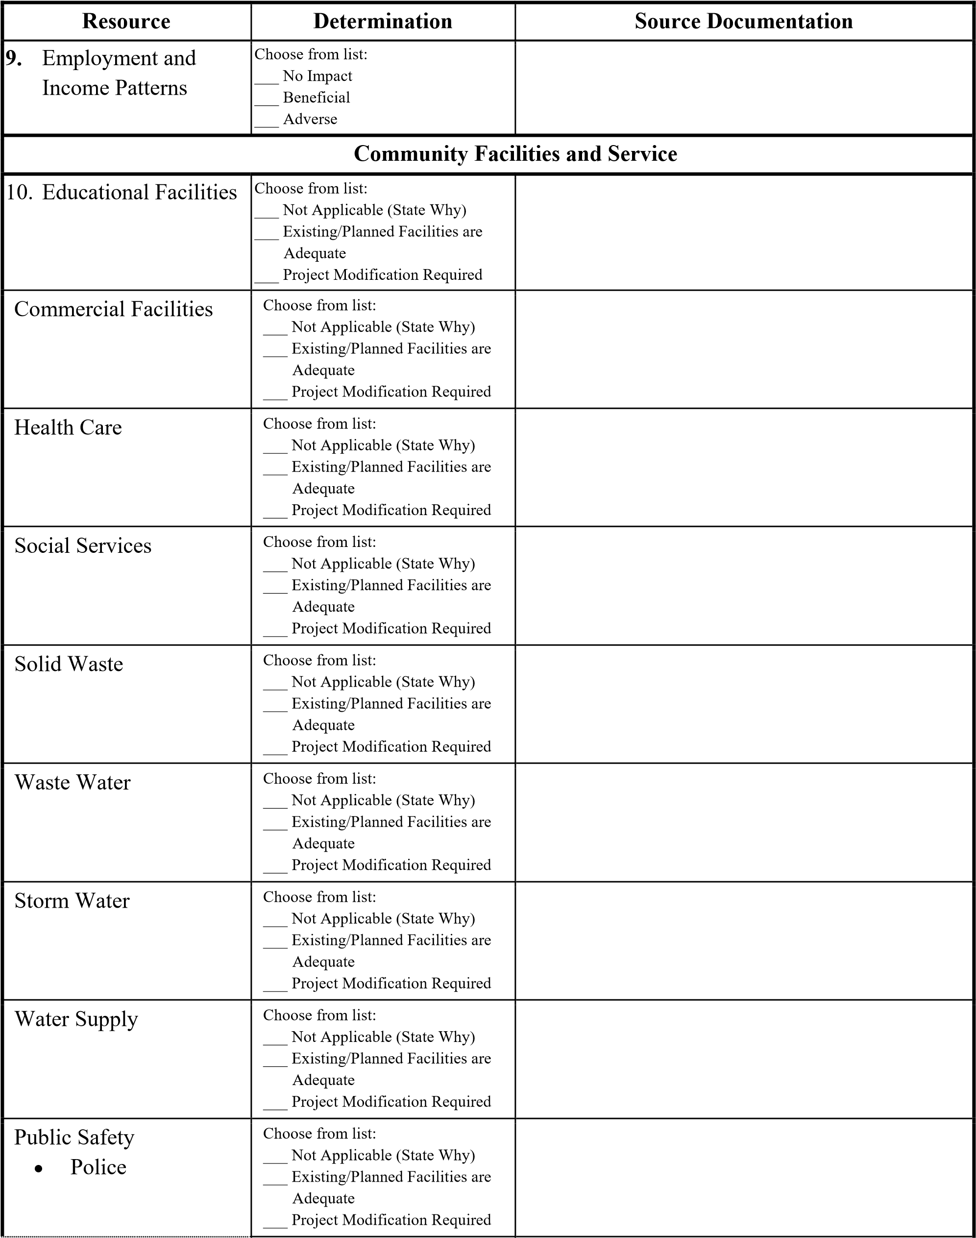

2 0 2 0 Community Development - CV - HVAC Program

Resource | Determination |  | Source Documentation
• Fire | Choose from list:  ___ Not Applicable (State Why)  ___ Existing/Planned Facilities are Adequate  ___ Project Modification Required
• Emergency Medical | Choose from list:  ___ Not Applicable (State Why)  ___ Existing/Planned Facilities are Adequate  ___ Project Modification Required
Open Space and  Recreation  • Open Space | Choose from list:  ___ Not Applicable (State Why)  ___ Existing/Planned Facilities are Adequate  ___ Project Modification Required
• Recreation | Choose from list:  ___ Not Applicable (State Why)  ___ Existing/Planned Facilities are Adequate  ___ Project Modification Required
• Cultural Facilities | Choose from list:  ___ Not Applicable (State Why)  ___ Existing/Planned Facilities are Adequate  ___ Project Modification Required
Transportation | Choose from list:  ___ Not Applicable (State Why)  ___ Existing/Planned Facilities are Adequate  ___ Project Modification Required
Natural Features
Water Resources | Choose from list:  ___ Not Applicable (State Why)  ___ No Impact  ___ Permit Required
Unique Natural Features and Agricultural Lands | Choose from list:  ___ Not Applicable (State Why)  ___ No Impact to or from Unique Natural Features  ___ Unique Natural Features Considered in Project Design  ___ Project Modification Required
Vegetation and Wildlife | Choose from list:  ___ Not Impact  ___ Beneficial ___ Adverse

