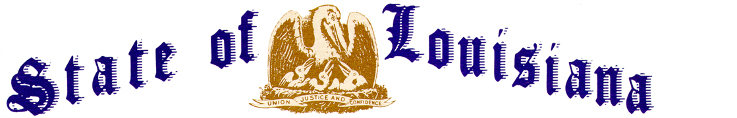
Executive Department
Office of the Governor
Executive Order Number JML 26-009
__________________________________________________________________________

STATE OF EMERGENCY
LICENSED BED CAPACITY FOR NURSING FACILITIES
________________________________________________________________________

WHEREAS, pursuant to the Louisiana Homeland Security and Emergency Assistance and Disaster Act, R.S. 29:721, et seq., a state of emergency was declared through Executive Order No. JML 26-006;
WHEREAS, the National Weather Service has issued a Winter Storm Watch for much of Louisiana, effective Friday, January 23, 2026, with mixed snow, sleet, and ice creating significant impacts in northern and central Louisiana;
WHEREAS, the National Weather Service has issued Cold Weather Advisories for much of Louisiana beginning Saturday, January 24, 2026, with additional advisories and updates anticipated as forecast confidence increases;
WHEREAS, icy precipitation and accumulations are forecast to create hazardous conditions that will severely impact roadways, cause tree damage, and lead to power and other infrastructure outages and damages;
WHEREAS, further impacts are anticipated due to cold temperatures, with hard freezes expected to persist for several days in the southern parishes of the State and subfreezing temperatures continuing for 70 to 90 hours in the northern parishes;
WHEREAS, prolonged freezing temperatures have potential to damage water systems, cause pipe failures, and disrupt essential services;
WHEREAS, extended power outages during periods of extreme cold present a serious threat to vulnerable populations;
WHEREAS, evacuations of nursing facilities, relocations of nursing facility residents, and admission to nursing facilities may be necessary during extended power outages, prolonged freezing temperatures, or hazardous winter conditions;
WHEREAS, the State of Louisiana desires to promote and protect the health, safety, and well-being of evacuees from this winter storm, and specifically those evacuees needing nursing facility services;
WHEREAS, the State of Louisiana desires to ensure the protection of such residents and evacuees in nursing facilities in times of declared emergencies;
WHEREAS, R.S. 40:2116.1(B)(1) prohibits the Department of Health from approving additional beds in nursing facilities;
WHEREAS, the State of Louisiana desires that residents and evacuees in nursing facilities be able to temporarily evacuate to safe sheltering locations during an emergency;
WHEREAS, the State of Louisiana, desires to minimize the impact of this winter storm on the residents of nursing facilities; and
WHEREAS, R.S. 29:724 authorizes the governor during a declared state of emergency or disaster to suspend the provisions of any state regulatory statute prescribing procedures for conducting state business, or the orders, rules or regulations of any state agency, if strict compliance with the provision of any statute, order, rule, or regulation would in any way prevent, hinder, or delay necessary action in coping with the emergency;
NOW THEREFORE, I, JEFF LANDRY, Governor of the State of Louisiana, by virtue of the authority vested by the Constitution and laws of the State of Louisiana, order and direct as follows:
Section 1: The provisions of R.S. 40:2116.1(B)(1) are hereby suspended for the purpose of allowing the Secretary of the Department of Health and the Louisiana Surgeon General, at their discretion, to establish such protocols, policies, and procedures as to allow a licensed nursing facility which accepts or receives evacuated residents to temporarily exceed its licensed bed capacity in the event of a declared emergency.
Section 2: The Secretary of the Department of Health and/or the Louisiana Surgeon General may establish such protocols, policies, and procedures without strict compliance with the requirements and provisions of the Administrative Procedure Act.
Section 3: This Order is effective upon signature and shall continue in effect from Friday, January 23, 2026, until Saturday, February 21, 2026, unless amended, modified, terminated, or rescinded earlier by the Governor, or terminated by operation of law.

IN WITNESS WHEREOF, I have set my hand officially and caused to be affixed the Great Seal of Louisiana in the City of Baton Rouge, on this 23rd day of January, 2026.

__________________________________________
JEFF LANDRY
GOVERNOR OF LOUISIANA

ATTEST BY THE
SECRETARY OF STATE

_____________________________________
Nancy Landry
SECRETARY OF STATE

