PAYROLL FORM AND STATEMENT OF COMPLIANCE
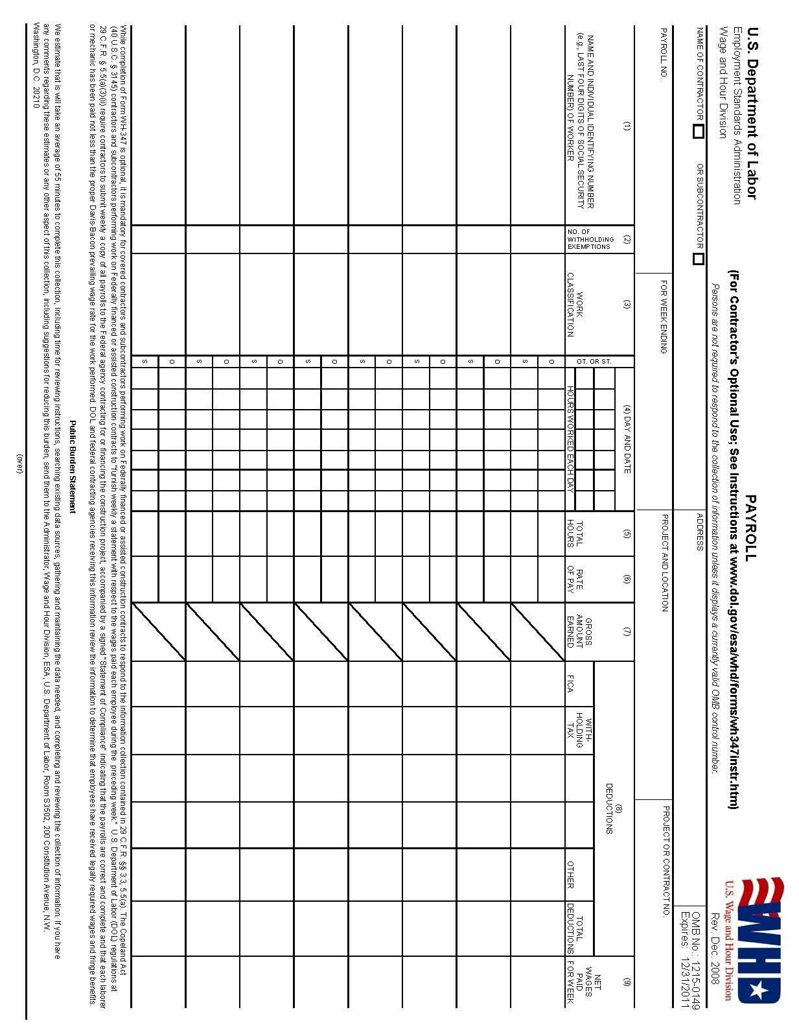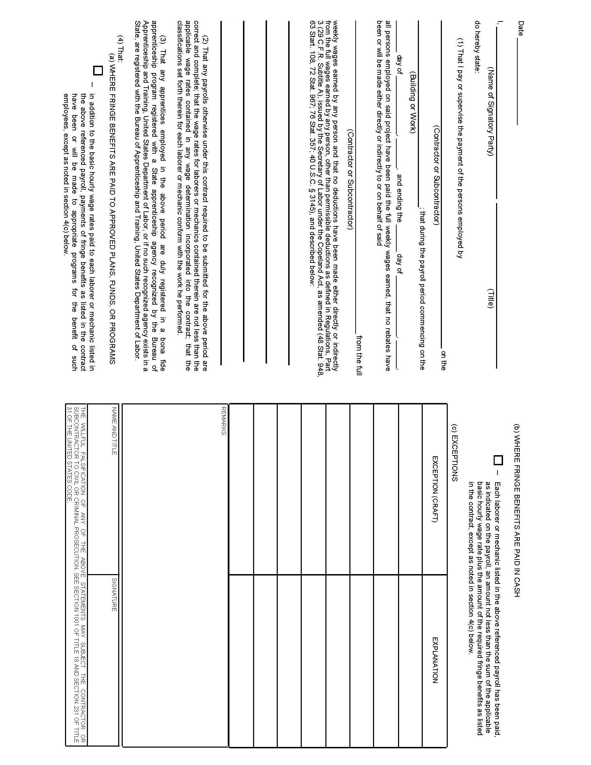
Comments Regarding the Payroll Form
(Prepared by the Labor Compliance Officer of the Office of Community Development)

General: Department of Labor Form WH-347 has been made available for the convenience of contractors and is not mandatory. Properly completed, this form will satisfy the requirements of the Disaster Recovery CDBG program. Form WH-347 along with instructions in greater detail can be found at: http://www.dol.gov/esa/whd/forms/index.htm.
Heading Information: Fill in the contractor name, address, payroll number, week ending date, project location, and Disaster Recovery CDBG project number.
Payrolls are numbered according to weeks having work activity. Example: Work was done during weeks one and two but the work was stopped due to rain during weeks three and four. Work resumed and the job was completed during week five. The payrolls for the entire project would be numbered 1-initial, 2, and 3-final. The prime contractor should inform the grantee’s Labor Compliance Officer, weekly, for any week during which there is no work done. “No work” payrolls are not required.
Column 1—Name and Last Four Digits of Social Security Number of Employee: In this block, enter the complete name, and the last four digits of the social security number of each employee.
Column 3—Work Classifications: Enter the classification as it is listed on the applicable Davis-Bacon wage decision. Note that “Operator” is not a proper classification since such a classification does not come directly from any wage decision. However, “Backhoe Operator” may be a proper classification if such a classification is on the applicable wage decision.
Columns 4 & 5—Hours Worked and Total Hours: Only enter hours worked on the Disaster Recovery CDBG project—not hours from any other job.
Column 6—Rate Per Hour: Enter the rate of pay on the Disaster Recovery CDBG project, including any cash paid in lieu of fringe benefits. When fringes are paid in cash, the preferred method is to differentiate between basic hourly pay and fringe benefits paid in cash in column 6 on the straight-time row. On the overtime row of column 6 enter the overtime rate of pay including amount paid in cash for fringes. An example follows where John Doe is paid $10.00 basic hourly rate with $3.00 in fringe benefits paid in cash. The overtime rate of $15.00 is 150% of the basic hourly rate of $10.00—then add the $3.00 for each hour of fringe benefits. The amout due for each overtime hour becomes $18.00. In contrast, if the basic hourly rate would not have been identified separately from the fringe and entered as a single figure of $13.00 then the 150% would have to be applied to the full $13.00 resulting in a higher overtime rate requirement of $19.50.
 |  | Column 6
John Doe | O | 18.00
John Doe | S | $10.00 3.00

Column 7—Gross Amount Earned: This column has blocks which are split into two parts, the upper left and the lower right. In the upper left portion of the block enter the gross amount earned from the Disaster Recovery CDBG project. In the lower right portion of the block enter the gross amount earned from all projects.
Column 8--Deductions and Column 9—Net Wages: Deductions are to be based on all projects, both Disaster Recovery CDBG and non-CDBG, and will be deducted from the weekly gross amount earned from all projects. Likewise, net wages are based on all projects.
The Second Page of WH 347—The Statement of Compliance:
The following instructions for the Statement of Compliance are quoted directly from the Department of Labor’s instructions that accompany the Payroll Form, WH 347.
FRINGE BENEFITS - Contractors who pay all required fringe benefits: A contractor who pays fringe benefits to approved plans, funds, or programs in amounts not less than were determined in the applicable wage decision of the Secretary of labor shall continue to show on the face of the payroll the basic cash hourly rate and overtime rate paid to his employees just as he has always done. Such a contractor shall check paragraph 4(a) of the statement on the reverse of the payroll to indicate that he is also paying to approved plans, funds or programs not less than the amount predetermined as fringe benefits for each craft. Any exceptions shall be noted in section 4(c).
Contractors who pay no fringe benefits: A contractor who pays no fringe benefits shall pay to the employee, and insert in the straight time hourly rate column of the payroll, an amount not less than the predetermined rate for each classification plus the amount of fringe benefits determined for each classification in the applicable wage decision. Inasmuch as it is not necessary to pay time and a half on cash paid in lieu of fringes, the overtime rate shall be not less than the sum of the basic predetermined rate, plus the half time premium on basic or regular rate, plus the required cash in lieu of fringes at the straight time rate. In addition, the contractor shall check paragraph 4(b) of the statement on the reverse of the payroll to indicate that he is paying fringe benefits in cash directly to his employees. Any exceptions shall be noted in Section 4(c).

Use of Section 4(c), Exceptions
Any contractor who is making payment to approved plans, funds, or programs in amounts less than the wage determination requires is obliged to pay the deficiency directly to the employees as cash in lieu of fringes. Any exceptions to Section 4(a) or 4(b), whichever the contractor may check, shall be entered in section 4(c). Enter in the Exception column the craft, and enter in the Explanation column the hourly amount paid the employee as cash in lieu of fringes and the hourly amount paid to plans, funds, or programs as fringes. The contractor shall pay, and shall show that he is paying to each such employee for all hours (unless otherwise provided by applicable determination) worked on Federal or Federally assisted project an amount not less than the predetermined rate plus cash in lieu of fringes as shown in Section 4(c). The rate paid and amount of cash paid in lieu of fringe benefits per hour should be entered in column 6 on the payroll. See paragraph on "Contractors who pay no fringe benefits" for computation of overtime rate.
An additional quotation from the US Department of Labor’s instructions for Form WH 347 regarding the Statement of Compliance states penalties for falsification.
Statement Required by Regulations, Parts 3 and 5: While this form need not be notarized, the statement on the back of the payroll is subject to the penalties provided by 18 USV 1001, namely, possible imprisonment of 5 years or $10,000.00 fine or both. Accordingly, the party signing this statement should have knowledge of the facts represented as true.

