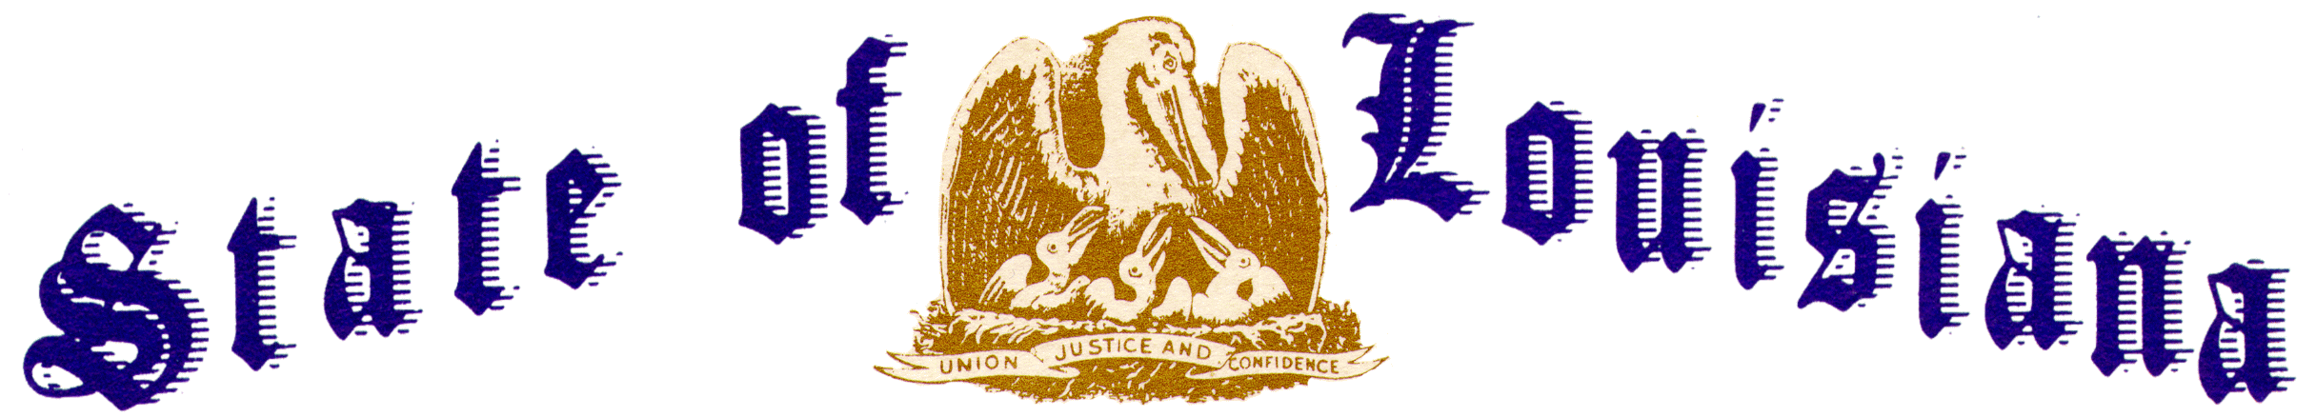

Executive Department
Office of the Governor
Executive Order Number JML 24-10
________________________________________________________________________________

FLAGS AT HALF-STAFF – REPRESENTATIVE JIMMY LONG
________________________________________________________________________________

WHEREAS, James Lucian “Jimmy” Long, a former distinguished member of the Louisiana House of Representatives, died on January 17, 2024;
WHEREAS, he was born May 29, 1946, to Jake and Marjorie Long and grew up in Farmerville;
WHEREAS, he graduated from Farmerville High School in 1964 and attended Louisiana Tech University;
WHEREAS, he married Phyllis Taunton and they had two daughters Rene’ and Dori; and
WHEREAS, he served as the Mayor of Farmerville from 1981-1984, as Louisiana State Representative from 1984-1988, and was the State Commissioner of LP Gas before going to work for Blue Cross and Blue Shield as a successful Insurance Agent in both Baton Rouge and Shreveport; and
WHEREAS, he was preceded in death by his parents, Jake and Marjorie Copeland Long; daughter, Dori Long Weaver; and brothers-in-law, Dr. Ralph Cooper and Chuck Acurio;
WHEREAS, he is survived by his wife of 57 years, Phyllis Taunton Long; daughter, Rene’ Long Auger (Kurt); grandchildren, Magen Auger Keys (Cody), Jake Auger (Jenny) and Brooks Auger. He is also survived by great-grandchildren Piper and Deacon Keys and Brooklynn Auger, as well as sisters Jeanette Long Cooper Wilbanks (Johnny) and Patti Long Acurio; and
WHEREAS, Jimmy Long’s service as a public servant and community leader to the State of Louisiana will long be remembered.
NOW THEREFORE, I, JEFF LANDRY, Governor of the State of Louisiana, by virtue of the authority vested by the Constitution and laws of the State of Louisiana, do hereby order and direct as follows:
Section 1: As an expression of respect and to honor Jimmy Long, the flags of the United States and the State of Louisiana shall be flown at half-staff over the State Capitol and all state buildings from sunrise until sunset on January 24, 2024.
Section 2: This Order is effective upon signature and shall remain in effect until sunset, January 24, 2024.

IN WITNESS WHEREOF, I have set my hand officially and caused to be affixed the Great Seal of Louisiana on this 23 day of January 2024.

_________________________________________
Jeff Landry
GOVERNOR OF LOUISIANA

ATTEST BY THE
SECRETARY OF STATE

_____________________________________
Nancy Landry
SECRETARY OF STATE

