**SRM VEHICLE PROCUREMENT PROCEDURES FOR LAGOV AGENCIES**

**IMPORTANT: Check order cutoff dates for the vehicle you wish to order on OSP website. This information will be posted on each line item as the dates become available from the vendor. Prior approval from LPAA must be obtained before entering order for OSP approval. LPAA approval document should be attached to the shopping cart.**

1. Agency completes an order sheet. Order sheets for each vehicle are linked on the [vehicle’s information page](https://www.doa.la.gov/doa/osp/agency-resources/vehicle-contracts/).
2. Agency creates shopping cart, entering the following:
   1. Agency creates shopping cart, selecting vehicle from MDM catalog. Ensure that the vehicle configuration chosen matches the vehicle configuration on the order sheet and the vehicle configuration approved by LPAA.

**Note:** Only the vehicle configurations listed on the order sheet and in MDM are available. Additional configurations may be added to the contract upon request. Send your request to [amy.gotreaux@la.gov.](mailto:amy.gotreaux@la.gov) You will be notified if the requested configuration is approved and added to the contract.

* 1. Agency selects P Group OSP One Time Buy Bid Team for the shopping cart item
  2. Agency selects LaGov Special Funding LEAF or MIPA if vehicle will be financed.
  3. Agency selects LPAA-Property Control as delivery address
  4. Agency completes all other required shopping cart header and accounting information (LPAA approval document and order sheet should be added to the shopping cart as an attachment)

1. Agency completes shopping cart items
   1. In the price field, enter the unit price shown on the order sheet.
   2. In supplier text, enter the option codes for any options being ordered under the text, “With the following options:”. Option codes are found on the order sheet. Enter the desired exterior and interior (if multiple exist) colors, the full agency name in which the vehicle shall be titled, and the agency’s contact person and telephone number. The vehicle description should not be changed. Failure to properly follow these instructions will delay your order**.**

**Note:** The vehicles come with standard OEM equipment and, in some cases, other options. Some additional options require LPAA approval. Only those options listed on the order sheet are available. Additional options may be added to the contract, send your

request to [amy.gotreaux@la.gov.](mailto:amy.gotreaux@la.gov) You will be contacted if the option is approved and added to the contract.

* 1. Attach LPAA approval document to item.
  2. LaGov agencies using Doc Tracking must check the vehicle box and enter the LPAA Approval Number under the Agency tab as shown below.

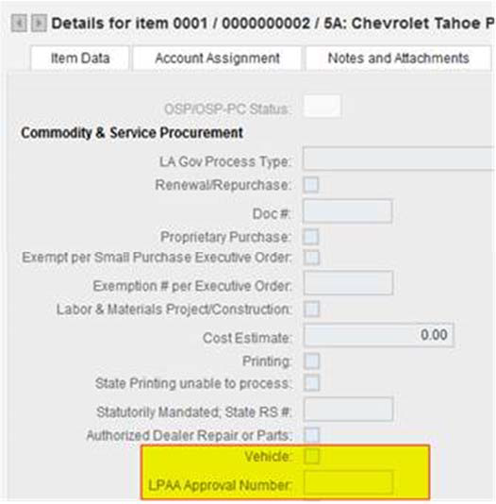

* 1. Order the shopping cart and agency approvals will be required.
  2. Once approved, OSP will begin processing the shopping cart.

1. Agency submits ProAct record ( Non Doc Tracking Agencies)
   1. Enter a ProAct record selecting One Time Buy as the Type of Procurement and Vehicles as a Special Condition. Under Required Documentation, enter the LPAA approval number and check the box indicating that the approval document has been uploaded in LaGov. If unable to upload the document in LaGov, upload the document in ProAct.
   2. Submit ProAct record to OSP.
   3. OSP will match ProAct record to approved shopping cart and deliver to Buyer. OSP will not begin processing the order until a ProAct record has been matched to an approved shopping cart.
2. Process Order for Approvals
   1. OSP will use the shopping cart to create a purchase order. OSP reviews the order for compliance with established guidelines and for necessary LPAA approvals.
   2. OSP will change the Goods Recipient to LPAA.
   3. OSP will select the LaGov Capital Asset box on the purchase order header for those agencies that are fully implemented on LaGov. **Note:** When the LaGov Capital Asset box is selected an approval will be generated by the system to the agency Asset Accountant who will approve the purchase order.
3. OSP P Group
   1. OSP P Group will ORDER the purchase order and workflow (approvals) will be started. Once approved the purchase order will encumber and print and OSP will sign and email copies to the Vendor, Agency and LPAA.
4. Delivery of Vehicle to Louisiana Property Assistance Agency (LPAA):
   1. LPAA inspects vehicle to ensure compliance with order specifications, and upon acceptance, **receives the vehicle in LaGov** (MIGO transaction) on behalf of the agency. LPAA will call the agency contact specified in PO supplier text to advise that the vehicle has been received in LaGov and is ready for pickup. Agency initiates payment process.

**NOTE:** LPAA will notify OSP if problems exist with the vehicle upon delivery, and will not create the MIGO document until the vendor correct the problem, thereby preventing payment. Agency will be notified in this event.

* 1. The **original invoice,** certificate of origin and odometer statement will be delivered to LPAA by the vendor. These original documents must be presented by the agency to the Department of Motor Vehicles for vehicle titling and registration purposes, and will be given to the agency at time of vehicle pickup.

**IMPORTANT NOTE:** Vendor will mail a copy of the invoice directly to the agency’s “Invoice to Address” stated on the purchase order. **Payments must be made within 30 days;** otherwise, the vendor has the right to repossess the vehicle from LPAA without recourse by the agency.

1. Vehicle Pickup from LPAA
   1. Agency must present a copy of transaction code FB03, reflecting that payment has been processed and indicating the check number prior to release of the vehicle. LPAA will verify the FB03 information.
   2. Agency to furnish the vehicle decals. LPAA will apply the agency’s decals to the vehicle prior to release.
   3. LPAA will release titling and registration documents at time of vehicle pickup.