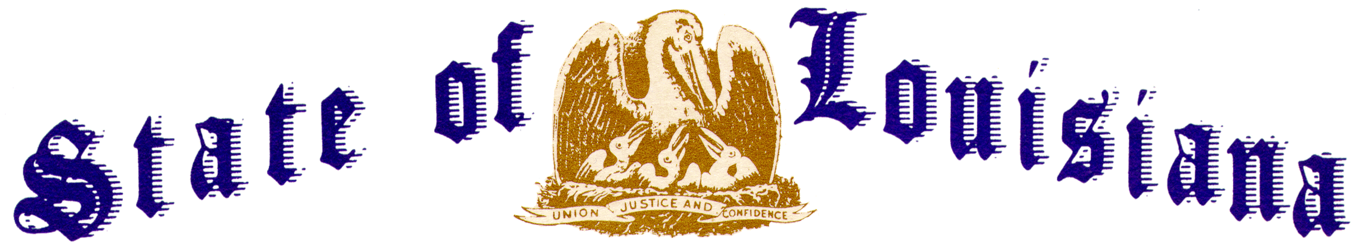

Executive Department
Office of the Governor
Executive Order Number JML 26-014
______________________________________________________________________________

BOND ALLOCATION 2026 CEILING AND CARRY-FORWARD BOND ALLOCATION 2025
______________________________________________________________________________

WHEREAS, Section 146 of the Internal Revenue Code of 1986, as amended (hereafter the “Code”), restricts the total principal amount of certain private activity bonds (hereafter the “Bonds”) that exclude interest from gross income for federal income tax purposes under Section 103 of the Code;
WHEREAS, Act No. 51 of the 1986 Regular Session of the Louisiana Legislature (hereafter “Act No. 51 of 1986”) authorizes the Governor to allocate the volume limit applicable to the Bonds (hereafter the “ceiling”) among the State and its political subdivisions in such a manner as the Governor deems to be in the best interest of the State of Louisiana;
WHEREAS, pursuant to Act No. 51 of 1986, Executive Order Number JML 2024-123 was issued to (a) provide for the manner in which the ceiling shall be determined, (b) establish the method to be used in allocating the ceiling, (c) establish the application procedure for obtaining an allocation of Bonds subject to such ceiling, and (d) establish a system of record keeping for such allocations;
WHEREAS, Section 4(G) of Executive Order Number JML 2024-123 provides that if the ceiling for a calendar year exceeds the aggregate amount of bonds subject to the private activity bond volume limit issued during the year by all issuers, by executive order, the Governor may allocate the excess amount to issuers or an issuer for use as a carry-forward for one or more carry-forward projects permitted under the Act;
WHEREAS, the sum of five hundred ninety-seven million seven hundred six thousand two hundred dollars ($597,706,200) represents the amount of the ceiling determined by the staff of the Louisiana State Bond Commission (“SBC”) for private activity bond volume limits for the year 2025 (“2025 Ceiling”);
WHEREAS, the sum of two hundred eleven million ten thousand seven hundred and eighty-seven dollars ($211,010,787.00) of the 2025 Ceiling was not allocated during the 2025 calendar year; and
WHEREAS, the sum of six hundred twenty-three million four hundred fifty-five thousand five hundred fifteen dollars ($623,455,515) represents the amount of the ceiling determined by the staff of the SBC for private activity bond volume limits for the year 2026 (“2026 Ceiling”).
NOW THEREFORE, I, JEFF LANDRY, Governor of the State of Louisiana, by virtue of the authority vested by the Constitution and the laws of the State of Louisiana, do hereby order and direct as follows:
Section 1: Pursuant to and in accordance with the provisions of Section 146(f) of the Internal Revenue Code of 1986, as amended, and in accordance with the request for carry-forward filed by the designated issuer, the excess private activity bond volume limit under the 2025 Ceiling is hereby allocated to the following issuer(s), for the following carry-forward project(s), and in the following amount(s):
 | ISSUER |  | CARRY-FORWARD PROJECT | CARRY-FORWARD AMOUNT
Louisiana Housing Corporation  Louisiana Public Facilities Authority  Louisiana Community Development Authority |  | Single Family Mortgage Revenue Bonds (Home Ownership Program) Series 2025A (Non-AMT)  Hyundai Steel Company  American Biocarbon |  | $75,000,000  $100,000,000  $36,010,787

Section 2: The allocation granted herein shall be used only for the bond issues described in Section 1 for the general purpose set forth in the “Application for Allocation of a Portion of the State of Louisiana’s Private Activity Volume Cap” submitted in connection with the bond issue described in Section.
Section 3: All references in this Order to the singular shall include the plural, and all plural references shall include the singular.
Section 4: This Order is effective upon signature and shall remain in effect until amended, modified, terminated, or rescinded by the Governor, or terminated by operation of law.

IN WITNESS WHEREOF, I have set my hand officially and caused to be affixed the Great Seal of the State of Louisiana in the City of Baton Rouge, on this 5th day of February, 2026.

__________________________________________
Jeff Landry
GOVERNOR OF LOUISIANA

ATTEST BY THE
SECRETARY OF STATE

__________________________________
Nancy Landry
SECRETARY OF STATE

