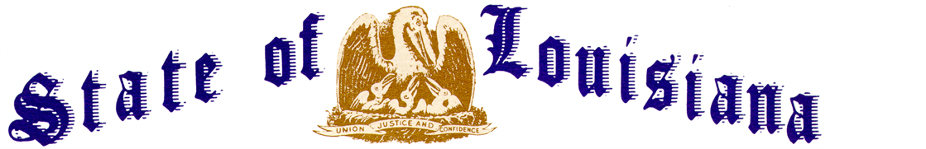
Executive Department
Office of the Governor
Executive Order Number JML 24-30
__________________________________________________________________________

DISASTER DECLARATION
CRAWFISH AQUACULTURE INDUSTRY
__________________________________________________________________________

WHEREAS, the Louisiana Homeland Security and Emergency Assistance and Disaster Act, R.S. 29:721, et seq., confers upon the Governor of the State of Louisiana emergency powers to deal with disasters including natural events that cause injury and property damage, such as those caused by hurricane, tornado, storm, flood, high winds and other weather related events;
WHEREAS, the Governor is responsible for meeting the dangers to the State and people presented by disasters;
WHEREAS, when the Governor determines that a disaster has occurred, or the threat thereof is imminent, R.S. 29:724(B)(l) empowers him to declare a state of disaster by executive order or proclamation, or both;
WHEREAS, on February 27, 2024, Congressman Troy A. Carter, Sr. requested that the Governor issue a statewide disaster declaration in the crawfish aquaculture industry to assist in securing federal resources;
WHEREAS, on February 28, 2024, Congressman Clay Higgins requested that the Governor issue a statewide disaster declaration to assist the impacted crawfish industry in obtaining access to federal resources;
WHEREAS, the State of Louisiana is the top producer of crawfish in the nation, generating an annual harvest between 175 and 200 million pounds;
WHEREAS, the crawfish industry in Louisiana contributes over $500 million annually to Louisiana’s economy;
WHEREAS, the State of Louisiana experienced extreme drought conditions and record temperatures with heat indices in the 100s through the summer and into the fall of 2023;
WHEREAS, the extreme drought conditions and the resulting lows in the Mississippi River resulted in saltwater intrusion from the Gulf of Mexico and the Intracoastal Waterway;
WHEREAS, 141 JBE 2023 declared a State of Emergency on August 11, 2023, due to the excessive heat, drought conditions, and saltwater intrusion and has been renewed and extended every thirty (30) days through Executive Order Number JML 24-28, which expires April 4, 2024;
WHEREAS, the President of the United States signed FEMA-3600-EM-LA on September 27, 2023, declaring Jefferson, Orleans, Plaquemines, and St. Bernard parishes to be impacted due to saltwater intrusion resulting from low water levels of the Mississippi River;
WHEREAS, in November of 2023, the LSU AgCenter compiled a preliminary estimate of the impact of drought and excessive heat on the Louisiana agriculture and forestry sectors;
WHEREAS, the LSU AgCenter found that over 46,300 crawfish acres could not be farmed due to saltwater intrusion, drought, and high temperatures;
WHEREAS, the LSU AgCenter projects that an additional 45,700 crawfish acres failed due to saltwater intrusion, drought, and high temperatures;
WHEREAS, approximately 365,000 crawfish acres have been affected by the conditions of saltwater intrusion, drought, and high temperatures;
WHEREAS, the LSU AgCenter predicts a statewide yield loss of 54% across the 365,000 affected crawfish acres;
WHEREAS, the exact fiscal impact to the State is indeterminable, and damages to the State’s crawfish agriculture industry alone are estimated to total $139.8 million;
NOW THEREFORE, I, JEFF LANDRY, Governor of the State of Louisiana, by virtue of the authority vested by the Constitution and laws of the State of Louisiana, order and direct as follows:
Section 1: Pursuant to the Louisiana Homeland Security and Emergency Assistance and Disaster Act, R.S. 29:721, et seq., a state of disaster is declared to exist in Louisiana.
Section 2: This disaster declaration shall be transmitted to the Administrator of the U.S. Small Business Administration and the Secretary of the U.S. Department of Agriculture.
Section 3: All departments, commissions, boards, agencies and officers of the State, or any political subdivision thereof, are authorized and directed to cooperate in actions the State may take in response to this event.
Section 4: This Order is effective upon signature and shall continue in effect from Tuesday, March 5, 2024, until Thursday, April 4, 2024, unless amended, modified, terminated, or rescinded earlier by the Governor, or terminated by operation of law.
IN WITNESS WHEREOF, I have set my hand officially and caused to be affixed the Great Seal of Louisiana in the City of Baton Rouge, on this 5th day of March, 2024.

__________________________________________
JEFF LANDRY
GOVERNOR OF LOUISIANA

ATTEST BY THE
SECRETARY OF STATE

_____________________________________
Nancy Landry
SECRETARY OF STATE

